**Product Dissection for Whatsapp:**

### **Company Overview:**

WhatsApp Inc. is a global messaging platform founded in 2009 by Brian Acton and Jan Koum. The company's mission is to provide a simple, secure, and reliable way for people to communicate with each other, regardless of their location or device.

WhatsApp revolutionised how people communicate by offering free, cross-platform messaging and calling services. It allows users to send text messages, voice messages, images, videos, and documents, and make voice and video calls over the internet, using their smartphones or computers.

In 2014, WhatsApp was acquired by Facebook Inc., but it continues to operate independently with its dedicated team. With over 2 billion monthly active users worldwide, WhatsApp has become one of the most popular messaging platforms globally.

### **Product Dissection and Real-World Problems Solved by Instagram:**

Overall, WhatsApp's range of features has successfully addressed various real-world communication challenges, providing users with a convenient, cost-effective, and secure platform for staying connected with others. Whether it's for personal communication, business collaboration, or community engagement, WhatsApp continues to play a vital role in facilitating communication worldwide.

WhatsApp, a leading messaging platform, has revolutionised communication worldwide by offering a range of features that address real-world challenges.

WhatsApp is committed to maintaining user privacy and security through end-to-end encryption, ensuring that only the sender and receiver can access the content of their messages. The platform also provides features like group chats, status updates, and integration with other services, making it a versatile communication tool for personal and business use.

WhatsApp's user-friendly interface, robust features, and focus on privacy have solidified its position as a leading messaging platform used by individuals, businesses, and organisations worldwide.

### **Case Study: Real-World Problems and Whatsapp's Innovative Solutions**

**1. Problem**: Cost-Effectiveness of Communication

**Problem Statement**: Traditional communication methods, such as SMS and phone calls, are often costly, particularly for international communication. This expense can create barriers to effective communication, especially for individuals and businesses with limited budgets.



**Solution**: WhatsApp offers a cost-effective solution for communication by utilizing internet data instead of traditional SMS. This approach significantly reduces communication expenses, especially for international messaging, making it more accessible and affordable for users worldwide. By leveraging internet connectivity, WhatsApp enables users to stay connected with friends, family, and colleagues without incurring high costs associated with traditional communication methods.

**2. Problem : Streamlining Group Communication**

**Problem Statement:** Coordinating group activities and discussions efficiently can be challenging with traditional communication methods. Managing multiple conversations and ensuring everyone stays informed can lead to confusion and delays in decision-making.

**Solution:** WhatsApp's group chat feature enables multiple users to communicate in one conversation, facilitating seamless collaboration and information sharing among groups. This feature streamlines group coordination, ensuring that everyone stays connected and informed in real-time. By centralising group communication within a single chat thread, WhatsApp eliminates the need for multiple conversations and reduces the risk of miscommunication, thereby enhancing the efficiency and effectiveness of group communication.

**3. Problem : Ensuring Privacy and Security**

**Problem Statement:** Privacy and security concerns are prevalent in digital communication, especially with the increasing threat of data breaches and unauthorised access to personal information. Users need assurance that their conversations and data are protected from prying eyes.

**Solution:** WhatsApp addresses these concerns by implementing end-to-end encryption for user communications. This means that only the sender and recipient can access the contents of their messages, ensuring that conversations remain private and secure. By prioritising user privacy, WhatsApp provides a trusted platform for confidential communication, mitigating the risks associated with digital privacy breaches. This encryption ensures that messages cannot be intercepted or accessed by third parties, enhancing user trust and confidence in the platform.

**4. Problem : Expressive Communication through Status Updates**

**Problem Statement:** Limited expression through traditional communication methods restricts users' ability to convey emotions and share experiences effectively. Text-based updates may not fully capture the richness and depth of users' thoughts and experiences.

**Solution:** WhatsApp's status updates feature allows users to share text, photos, videos, and GIFs with their contacts for 24 hours. This enables users to express themselves creatively and share updates about their lives in a more engaging and expressive manner. By providing various multimedia options for status updates, WhatsApp enhances users' ability to convey emotions and share experiences effectively, addressing the limitations of traditional text-based communication. This feature provides users with a dynamic platform to share their current activities, feelings, and experiences with their contacts, fostering deeper and more meaningful connections.

**5. Problem: Simplified File Sharing**

**Problem Statement:** Sharing various types of files through traditional communication methods can be cumbersome and inefficient, leading to delays and limitations in collaboration. Users may encounter difficulties in sending and receiving files, especially large or complex documents.

**Solution:** WhatsApp simplifies file sharing by allowing users to send photos, videos, documents, and voice recordings directly through the platform. This streamlined approach eliminates the need for separate file-sharing services or email attachments, making collaboration more efficient and seamless. By providing a convenient and intuitive interface for file sharing, WhatsApp enhances productivity and facilitates smoother communication among users, overcoming the challenges associated with traditional file-sharing methods. This feature enables users to share files quickly and easily, enhancing collaboration and communication in personal and professional settings.

#### **Conclusion:**

In conclusion, WhatsApp has effectively addressed various real-world communication challenges through its innovative features and solutions. By offering cost-effective messaging, streamlined group communication, robust privacy and security measures, expressive status updates, simplified file sharing, and high-quality voice and video calls, WhatsApp has transformed the way people connect and communicate globally. These features not only enhance the efficiency and convenience of communication but also foster deeper connections and meaningful interactions among users. With its user-centric approach and commitment to providing a reliable and secure platform, WhatsApp continues to be a leading messaging platform, empowering users to stay connected and engaged with others in today's digital world.

### **Top Features of Whatsapp:**

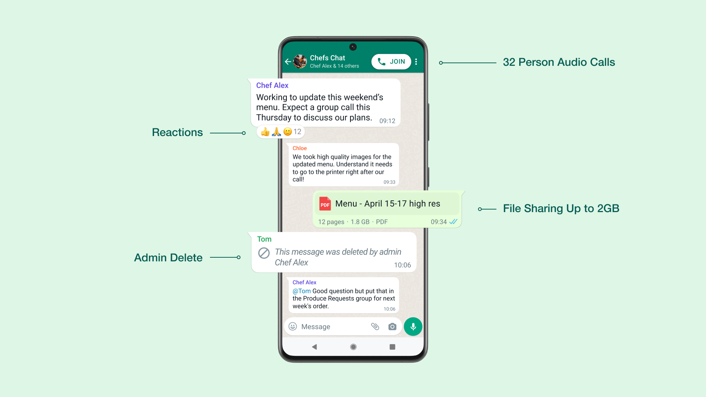

1. **Messaging:** WhatsApp allows users to send text messages, voice messages, images, videos, documents, and location information to individuals and groups.
2. **Voice and Video Calls:** Users can make free voice and video calls to other WhatsApp users over the internet, providing a cost-effective alternative to traditional phone calls.
3. **Group Chats:** WhatsApp supports group chats where multiple users can communicate in one conversation, making it easy to stay connected with friends, family, and colleagues.
4. **Status Updates:** Users can share text, photos, videos, and GIFs as status updates visible to their contacts for 24 hours, enabling them to express themselves creatively and share updates about their lives.
5. **End-to-End Encryption:** WhatsApp employs end-to-end encryption for user communications, ensuring that only the sender and recipient can access the contents of their messages, enhancing privacy and security.
6. **File Sharing:** WhatsApp allows users to share various file types, including photos, videos, documents, and voice recordings, directly through the platform, facilitating easy and convenient file sharing.
7. **Voice Messages:** Users can record and send voice messages to contacts, providing a convenient way to communicate when typing is not practical.
8. **WhatsApp Web:** WhatsApp Web allows users to access their WhatsApp account on a computer browser, enabling them to send and receive messages seamlessly across devices.
9. **WhatsApp Business:** WhatsApp Business provides businesses with tools to communicate with customers, including automated messages, quick replies, and business profiles.
10. **Location Sharing:** Users can share their current location or a live location with contacts, making it easy to coordinate meetups or share travel updates.

### **Schema Description:**

The schema represents a simplified database model for a WhatsApp. It includes tables for users, chats, messages, groups, calls, and status updates. Key attributes such as user IDs, chat IDs, message content, group names, call types, and status update content are stored. Relationships are established via foreign keys to track user participation in chats, message content within chats, group creation, calls made and received, and status updates posted.

**User:**

* **UserID (PK):** Unique identifier for each user.
* **Username:** Display name chosen by the user.
* **Phone_Number:** Phone number associated with the user's account.
* **Profile_Picture:** Image chosen by the user to represent their profile.
* **Status:** Text status set by the user, visible to contacts.

**Chat:**

* **ChatID (PK):** Unique identifier for each chat.
* **Last_Message_Time:** Timestamp of the last message in the chat.

**Message:**

* **MessageID (PK):** Unique identifier for each message.
* **ChatID (FK):** ID of the chat the message belongs to.
* **SenderID (FK):** ID of the user who sent the message.
* **Content:** Text content of the message.
* **Timestamp:** Timestamp of when the message was sent.

**Group:**

* **GroupID (PK):** Unique identifier for each group.
* **CreatorID (FK):** ID of the user who created the group.
* **Group_Name:** Name of the group.
* **Description:** Description of the group.
* **Creation_Time:** Timestamp of when the group was created.

**Call:**

* **CallID (PK):** Unique identifier for each call.
* **CallerID (FK):** ID of the user who initiated the call.
* **ReceiverID (FK):** ID of the user who received the call.
* **Type:** Type of call (voice or video).
* **Duration:** Duration of the call.
* **Timestamp:** Timestamp of when the call was made.

**Status_Update:**

* **UpdateID (PK):** Unique identifier for each status update.
* **UserID (FK):** ID of the user who posted the status update.
* **Content:** Text, photo, video, or GIF content of the status update.
* **Expiry_Time:** Timestamp of when the status update expires

**Relationships are:**

* Each Chat can have multiple Messages (one-to-many relationship).
* Each User can be the Sender of multiple Messages (one-to-many relationship).
* Each User can be the Creator of multiple Groups (one-to-many relationship).
* Each Group can have multiple Users (many-to-many relationship).
* Each User can make multiple Calls as a Caller (one-to-many relationship).
* Each User can receive multiple Calls as a Receiver (one-to-many relationship).
* Each User can post multiple Status Updates (one-to-many relationship).

**ER Diagram:**

Let's construct an ER diagram that vividly portrays the relationships and attributes of the entities within the Instagram schema. This ER diagram will serve as a visual representation, shedding light on the pivotal components of Instagram's data model. By employing this diagram, you'll gain a clearer grasp of the intricate interactions and connections that define the platform's dynamics.

### 

### **Conclusion**

In this case study, we explored the schema design and Entity-Relationship diagram of WhatsApp. WhatsApp's mission to provide a simple, secure, and reliable means of communication has resonated with over 2 billion monthly active users worldwide. By examining the schema encompassing entities such as users, chats, messages, groups, calls, and status updates, we've gained valuable insight into the platform's architecture and functionality. WhatsApp's innovative features, including cost-effective messaging, streamlined group communication, robust privacy measures, expressive status updates, and simplified file sharing, effectively address real-world communication challenges. Its acquisition by Facebook Inc. in 2014 has bolstered its resources while maintaining operational autonomy, further fueling its growth and global reach. By comprehensively understanding WhatsApp's schema, we appreciate how it manages the intricacies of user interactions and data sharing, contributing to its widespread adoption and enduring success in the realm of messaging applications.

Video link - <https://drive.google.com/file/d/12gf1WuwyjsqJvy0HKtj_7djVa7ysUhOV/view?usp=sharing>